Chapter 13, Solution 65.

40

10 I₁ 1:2 I₂ 50 I₂ 1:3 I₃

1  +  2
+ + + +
200 V V₃ V₄
(rms) V₁ V₂ - - 20
- - -


At node 1,

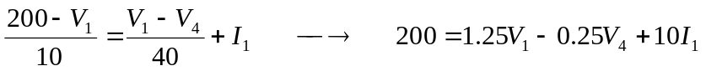 (1)

At node 2,

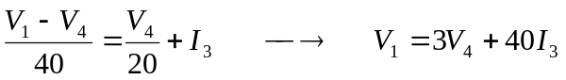 (2)

At the terminals of the first transformer,

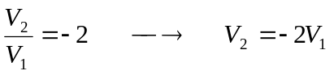 (3)
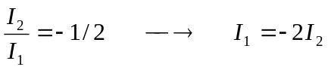 (4)

For the middle loop,

(5)

At the terminals of the second transformer,

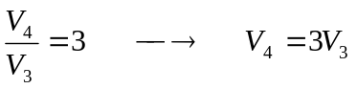 (6)

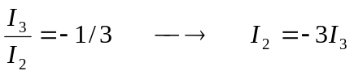 (7)
We have seven equations and seven unknowns. Combining (1) and (2) leads to

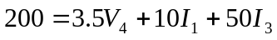

But from (4) and (7), 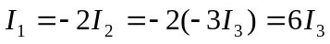. Hence

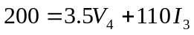 (8)

From (5), (6), (3), and (7),

Substituting for V₁ in (2) gives

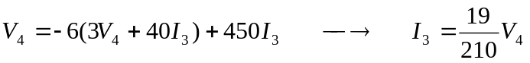 (9)

Substituting (9) into (8) yields

